EDA (Exploratory Data Analysis)

WEEK - 1

REPORT

SUBMITTED BY:

- SAHANAA SREE

E25DA045

WEEK - 1

Problem Statement :

The Superstore dataset contains sales, customer, product, and order details that need to be cleaned and organized. The project aims to improve data quality and create meaningful visualizations to understand sales performance and business trends.

2. Objective

To clean and transform the Superstore dataset using Power Query
To remove errors and maintain correct data types.
To analyze sales, profit, products, customers, and regions.
To create an interactive Power BI dashboard for better business understanding.

- Tasks and Deliverables

Import the Superstore dataset into Power BI

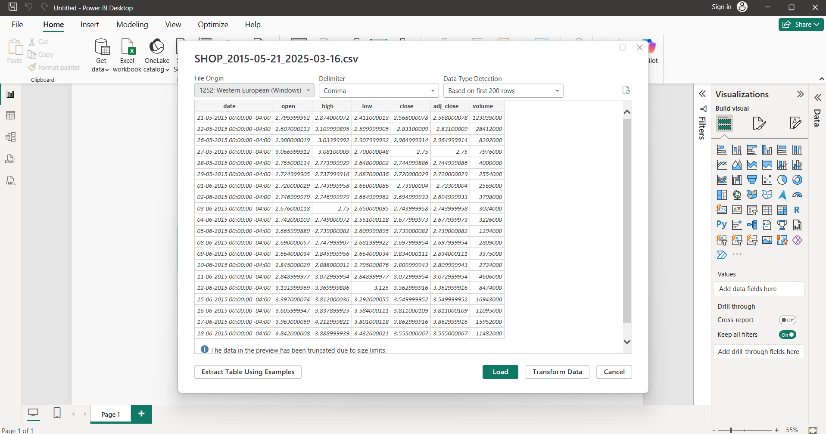

4 . Clean and format the data using Power Query

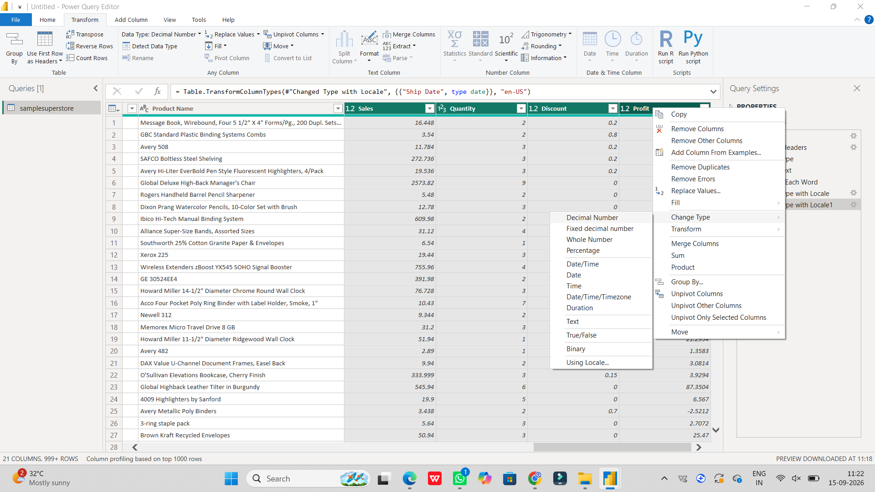

- Trim text, change data types, and format date columns.

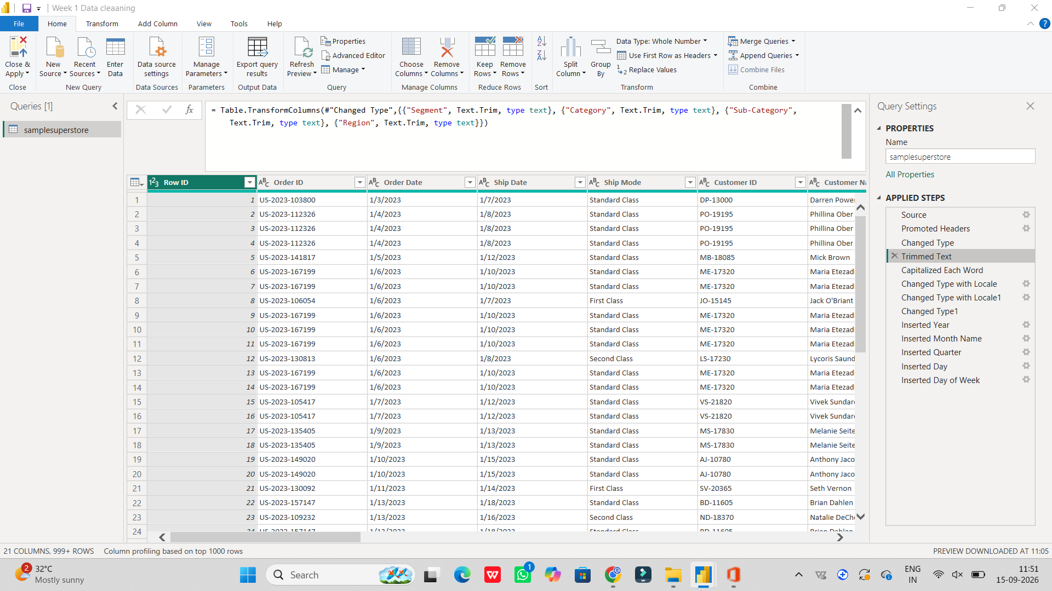

- Create additional columns such as Year, Month Name, Quarter, Day, and Day of Week.

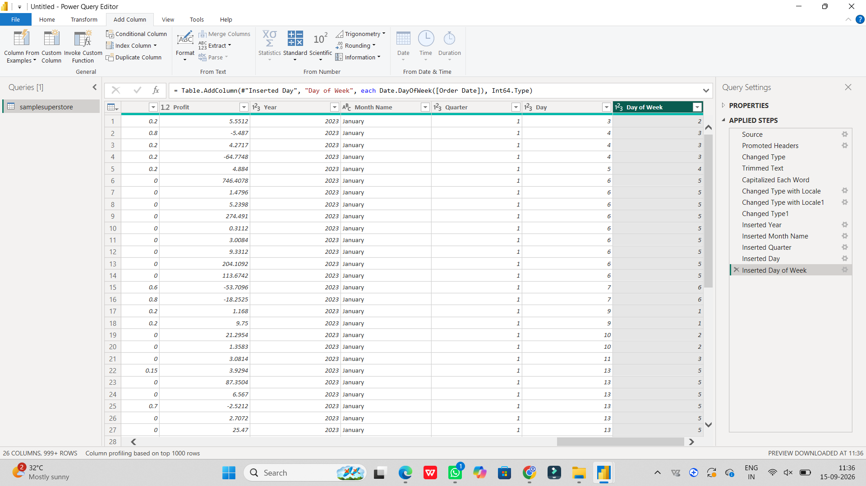

Create charts and visualizations for sales, products, customers, and cities.

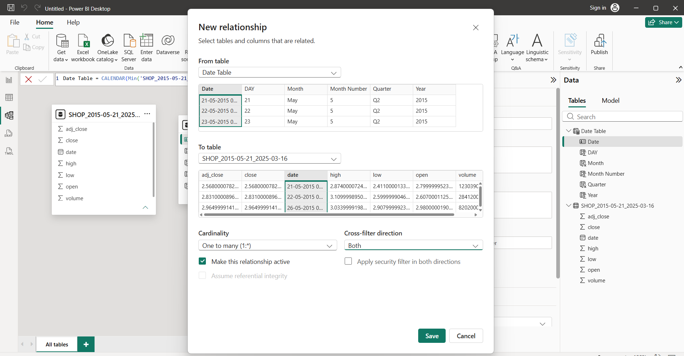

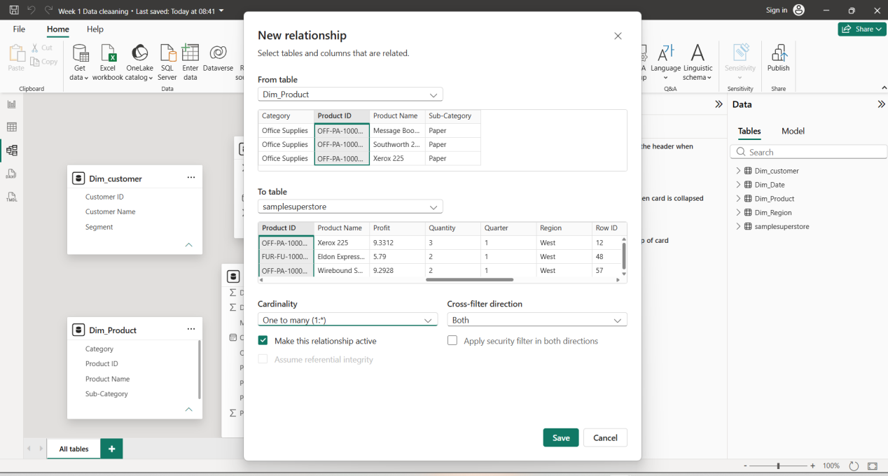

CONCLUSION :

The project helped in understanding data cleaning and transformation using Power Query. The Power BI dashboard provides useful insights into sales trends, product performance, and customer distribution, supporting better business decisions.

